**DR. APJ ABDUL KALAAM TECHNICAL UNIVERSITY -AKTU**

**CENTER FOR ADVANCED STUDIES (CAS)**

**VISIT**

On the day of 22/09/2023 (Friday),

40 selected students from BCA, BSc (computer science) and BSc (physics and electronics) along with the teachers of respective faculties of National Post Graduate College visited the AKTU-CAS campus which is famous for its high-tech labs and technology. We reached the destination by 11:00 am and were welcomed by the AKTU’s top professors and staff.

Firstly, we had an introductory session with the lab assistants and professors where we discussed about the entire campus of CAS. It was established in 2017 and occupies multiple floors of well-defined infrastructure with facilities like Digital Library, State Innovation Hub, Clean Room and much more. Further we were given a short pre-sight of the labs and technologies that we were going to explore.

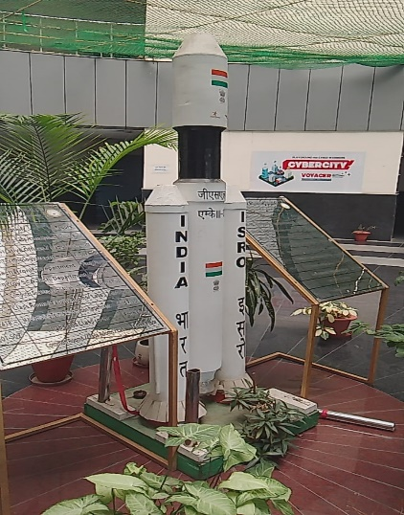 The campus tour started with a marvelous model of the recent most successful project of INDIA i.e. **THE CHANDRAYAAN-3** to celebrate and embrace the success of our country. The Indian Space Research Organization (ISRO) worked really hard to achieve such great milestone which other countries could only dream of doing so.

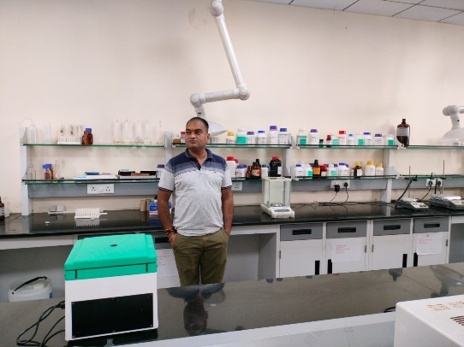Next, we headed over to the **NANO-Tech department** which constituted of a number of facilities. Starting with the **Material Synthesis Laboratory** where synthesis of different materials is performed with the help of a various chemicals. The laboratory was equipped with very high-tech machineries like the water-deionizer for ultra purifying the water quality for further test processes, a Fume hood which is used to extract and expel out the harmful fumes generated by the reaction of chemicals, there were microwave ovens, huge furnaces, pH meter and many more machineries for performing complex chemical reactions.

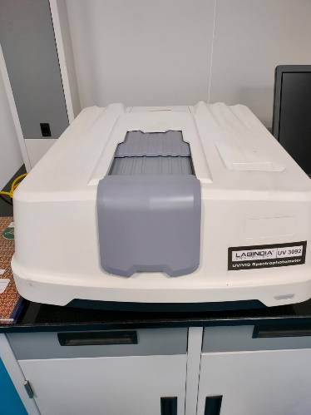After the synthetization we saw the **Material Categorization Laboratory**, the functions of this lab are relatively complex, which includes a number of processes done on the synthesized material to prepare it for further experimentational purposes. It was equipped with many high-tech auto machines like Dip Coater, Pico Meter, Nano Fiber Electrospinning Unit etc.

The next facility was the **Clean Room**, as the names suggests, the clean room was a specialized room where research is performed on nanoscopic level of materials with machineries like Scanning Electron Microscope and UV/IR Spectrophotometer. Even small particles of dust would hinder such research works and that is the reason why this work 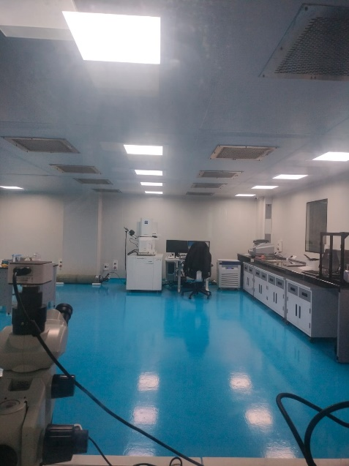needs to be performed in a very clean room. To provide such environment, the lab was equipped with 4 advanced air filters which constantly purify the air of the laboratory in real-time and even the temperature of the room was controlled to a high precision. Since it was a very sensitive place, outside visitors were prohibited from entering the facility. It was one of the many protocols followed by the facility.

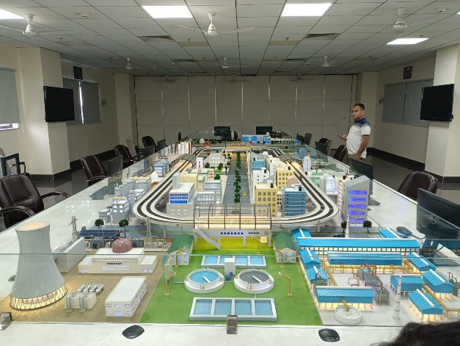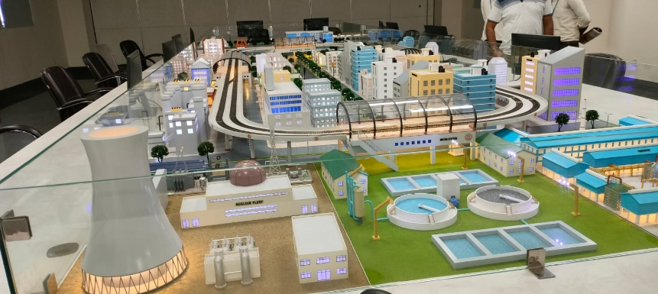Moving on further we reached the **Mechatronics Department**, it is actually a multidisciplinary field that refers to the skill sets needed in advanced automated manufacturing industry. It is the intersection of mechanics, electronics and computing to create simpler, smarter systems. The department constituted a very high-tech **Cyber Security Laboratory**. Upon entering the lab, we encountered a marvelous model of a fine-tuned smart city infrastructure. It was designed to research upon the various cyber attacks which could potentially harm the entire city, every small detailing of the smart city model was fully functional with various microprocessors like Arduinos and rasberrypies. The concept of cyber security in smart cities is very interesting where the faculty divides the experts in two groups of **Hackers** and **Defenders**. The goal of hackers is to find the loop holes in the system and breach the security while the Defenders prevent them from doing so.

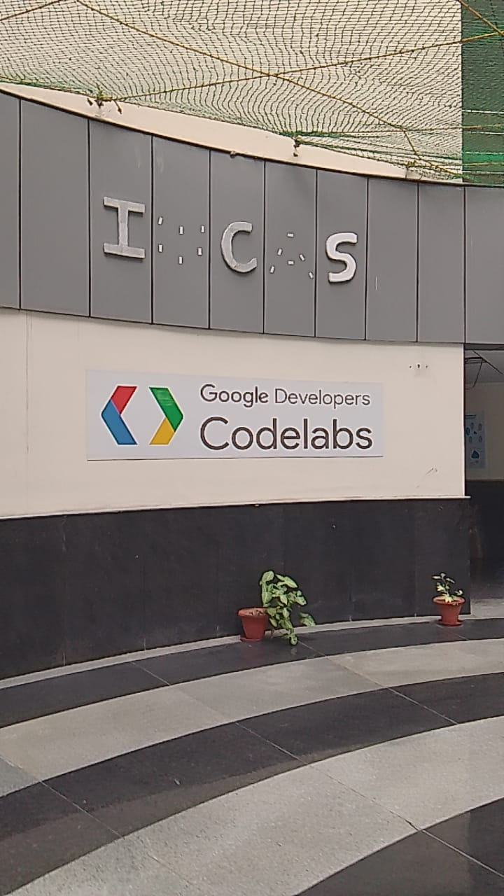After having the tremendous sight of such high-tech model, we headed over to the lab of one of the most famous TECH-GIANT of the world which is none other than GOOGLE. The facility is actually called **Google Code Labs.** It was occupied with high performance computers for Competitive Programming and Developments. Google is also famous for providing its employees with a very mind-refreshing environment so that the coders can focus well without getting into boredom. The entire facility was funded and setup by GOOGLE itself.

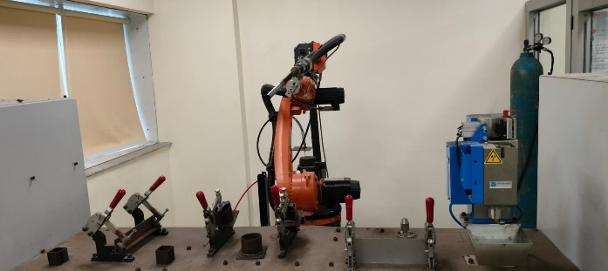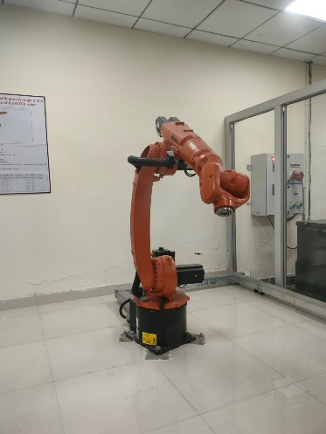The next faculty was the **Industrial Automation Department**, it basically consisted of Fully automated Robots and Machineries to automate the work of a human in an industry. The Laboratory comprised of Three sections of Robots; all the sections of lab had the Single Armed Robots which were named **KUKA ROBOTS.** In the first compartment was the Pick-And-Place robot, secondly it was the welding robot and the final compartment of the KUKA robot arm was the warehouse robot which was a helper arm, these robotic arms provided a 6-degree motion freedom meaning we can make them move in any direction and we can even specify the speed of its movement, the maximum speed of single armed KUKA robot is 1300m/sec which is insanely fast.

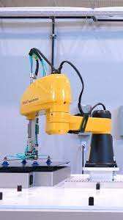 In the same department, there exists another robotic laboratory which is the **Multi-Robotic System Laboratory,** this lab consisted of a number of robotic equipment. One of them was the **Dual Armed Robot: SCARA**. Scara is also a pick and place robot but its supreme value was that it overcame the limitations of KUKA robot’s one arm by having a dual armed structure which allows SCARA to have an even efficient robotic movements which can easily boost industrial productivity.

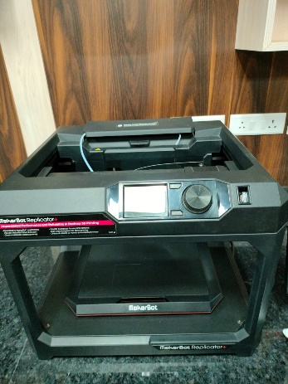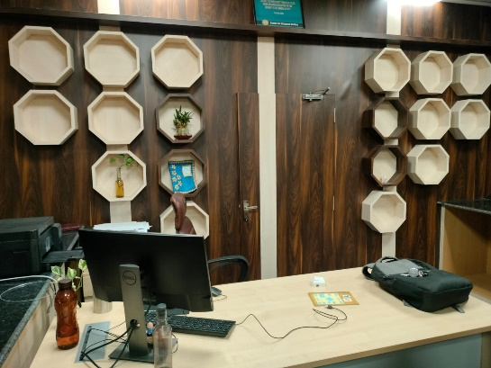 Moving ahead, we visited the **3D printing laboratory**. As per the name, the laboratory was equipped by various types of high-tech 3D printers like the Metallic 3D printers and PolyJet 3D printers. This laboratory was very unique and special because at the time of infamous global pandemic i.e., the Corona Virus, the professors and researchers worked in this lab to provide various health aids for the patients. The made custom face shields which had a very low market price and people could afford it easily, they even invented a framework that enabled a ventilator to be shared with upto 4 beds simultaneously. This research and hard work actually saved the lives of many patients who were suffering from the virus. At the time all the Big Politicians of UP were also present in the laboratory of AKTU to finalize the official deployment of their cures.

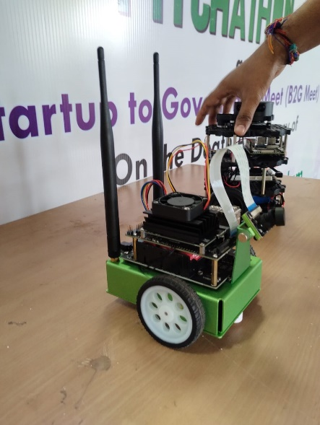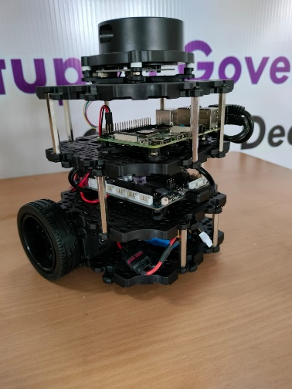 Next, we had a very interesting visit in the **Sensor Drive and Control Laboratory**, this lab was comprised of small automated robots which were equipped with various microprocessors like Arduinos, Rasberrypies and ESP-32 etc. The robots could perform various functionalities and were categorized accordingly, like the line-following robots, area mapping and surface analyzer robots and much more. They even build drones and other advanced microcontroller-based robots. One of the robots was a area-mapper bot which was provided by one of the famous company NVIDIA that had some high-tech features including Computer Vision etc. The same laboratory also constituted of Under Water Robotics as well as some other advanced machinery setups like the Electro Pneumatic Trainer and the Advance Electro Hydraulic Trainer.

Last but not the least, we visited the most interesting laboratory of the entire CAS faculty, it was the **Artificial Intelligence Laboratory**.The AI Lab is the heart of the CAS as it holds the most special of all machines i.e. A **5-PetaFlop processor computer.** This beast can perform 10 15 Operations in a single second. Its specifications were also mind blowing with a 30 Terabyte Solid State Drive. 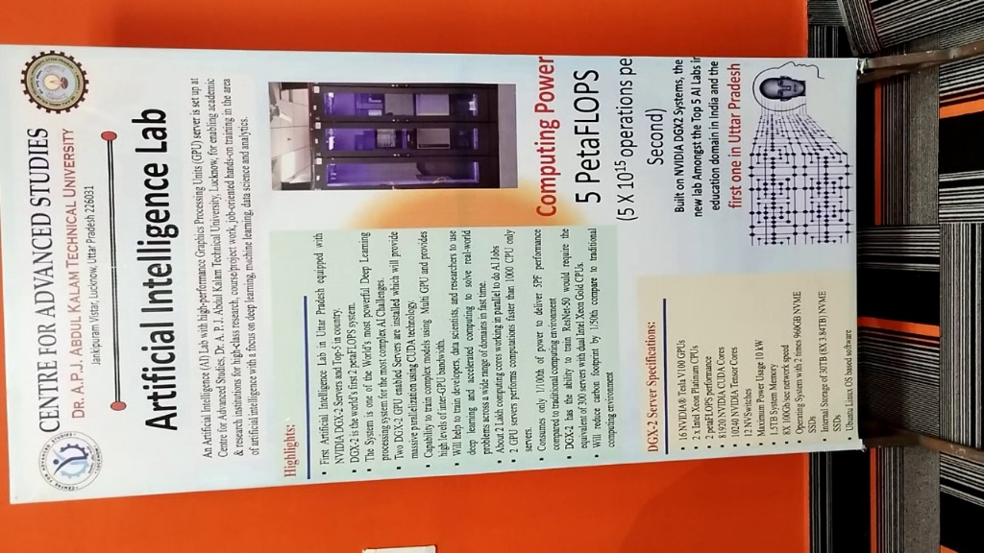Such processing power is required to train Machine-Learning Models with a huge dataset. With normal computers it would be a nightmare to handle such big data but with a 5-petaflop computer, even terabytes worth of dataset can be trained in the models in just seconds. Along with this heavy processor, we also had a sight of a prototype small equipment which was actually an assistive device for visually impaired people. The device was able to differentiate between objects within its range and tell the person what the object actually is. It was designed with various technologies like Computer Vision and Machine Learning.

Overall, we had a very great experience through this visit of AKTU-CAS provided by our National Post Graduate College, and we came to learn so many new things related to modern day technology and developments.